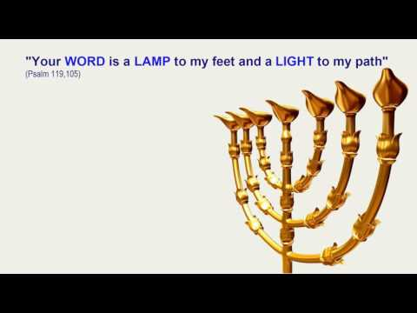
Congregation Sof Ma’arav P.O. Box 10850 Honolulu HI 96817
A Tribute Roast & Toast Celebration in Honor of
Donald J. Armstrong
For his decade of leadership as President of Congregation Sof Ma’arav
Sunday, August 12, 2018 5:30 PM to 8:30 PM
Kuapa Isle Club House* 156 Opihikao Way Hawaii Kai 96825
Food, gourmet desserts, champagne toast, soft drinks, punch, & beer available
BYO Wine if desired
An Invitation to all members Sof Ma’arav
Space limitations: Be sure to RSVP by July 23, 2018 to Risa Dickson 909-957-5053 drrisad@gmail.com
If unable to attend, please submit your Roast and/or Toast to
Alan or Pam Kosansky at
akosansky@profitpt.com or pam@profitpt.com 58 Kuuala Street Kailua HI 96734
*Directions to Kuapa Isle Club House: From Kalanianaole Highway turn onto Hawaii Kai Drive. Take 7th right onto Opihikao Way. Go through guard shack and take immediate right continuing on Opihikao Way to end. Park on basketball court and head to nearby Club House next to swimming pool.
For further information, contact Mathew Sgan newmat@aol.com 808-286-9016

